**EEDG/CE 6370**

**Due Date**: Sunday November 23, 11:59pm– Submit this editable **Word** document NOT pdf

0

18

**Design and Analysis or Reconfigurable Systems**

**Homework 8 – Hard Processor System**

**Name: Yuyang Hsieh**

**Email: yxh230019@utdallas.edu**

**Part I - Linux**

Install any of the Linux versions on the SD card and show that it is working. Include a picture of the working Linux terminal. Include your UTD student card in the picture to make sure it is your work.

|  |
| --- |
| Marks |
| 2 |
|  |

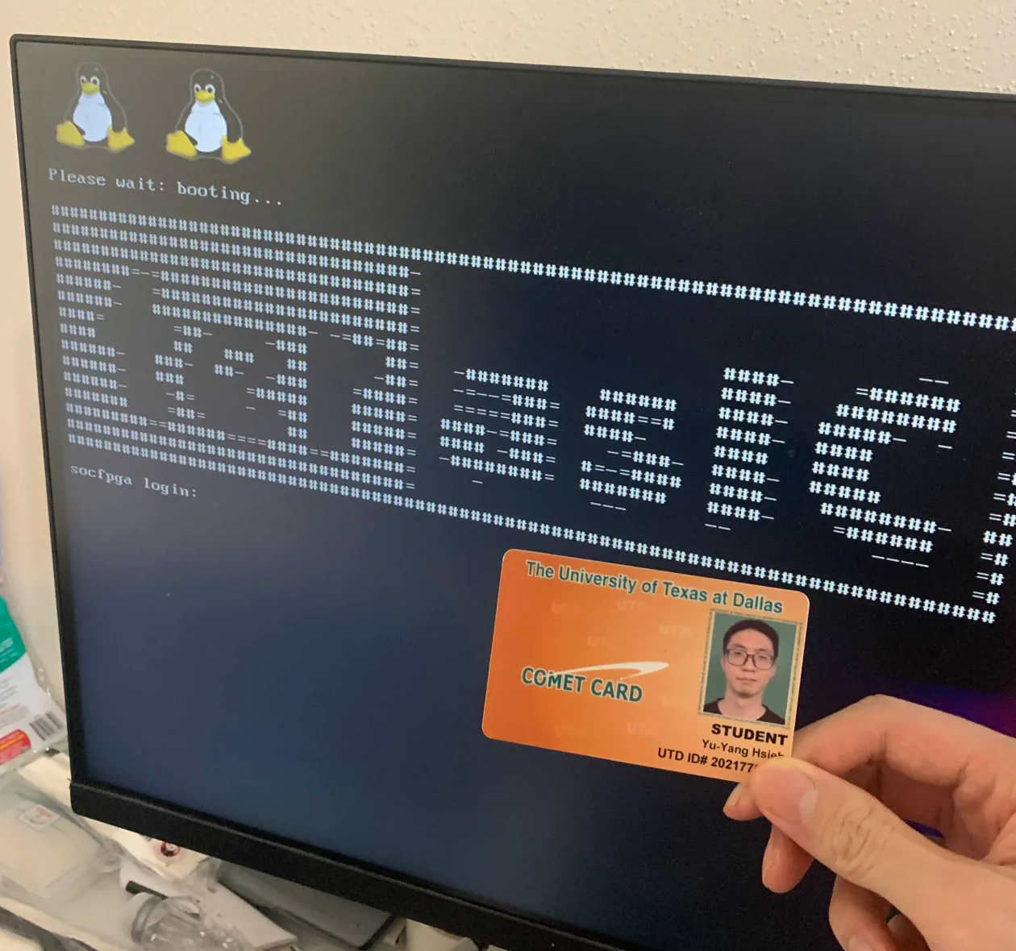  
Fig1: working Linux terminal (student id: 2021775024)

**Part II – Simple program**

Write a simple “Hello FPGA friends. I LOVE this class” Program” and compile and run it on the HPS of the FPGA. Report the size of the compiled file. Include screenshots the compilation process and working design runs correctly on the FPGA.

|  |
| --- |
| Marks |
| 4 |
|  |

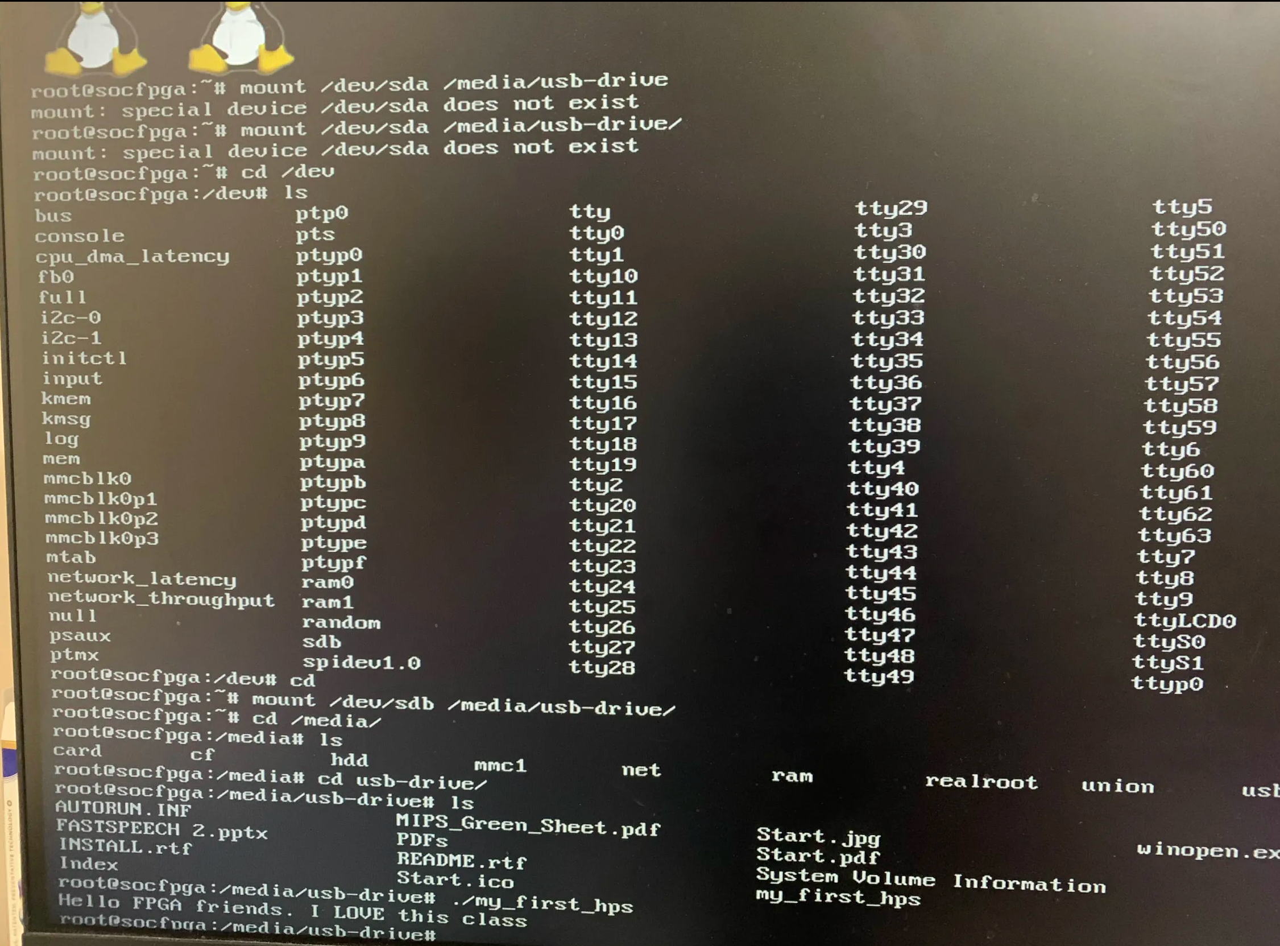  
Fig2: compilation process   
1. Detect the USB drive:  
fdisk -l  
2. Create a mount point:  
mkdir /media/usb-drive  
3. Mount USB drive:

$mount /dev/sdb /media/usb-drive  
4. cd /media/usb-drive

ls

./my_first_hps

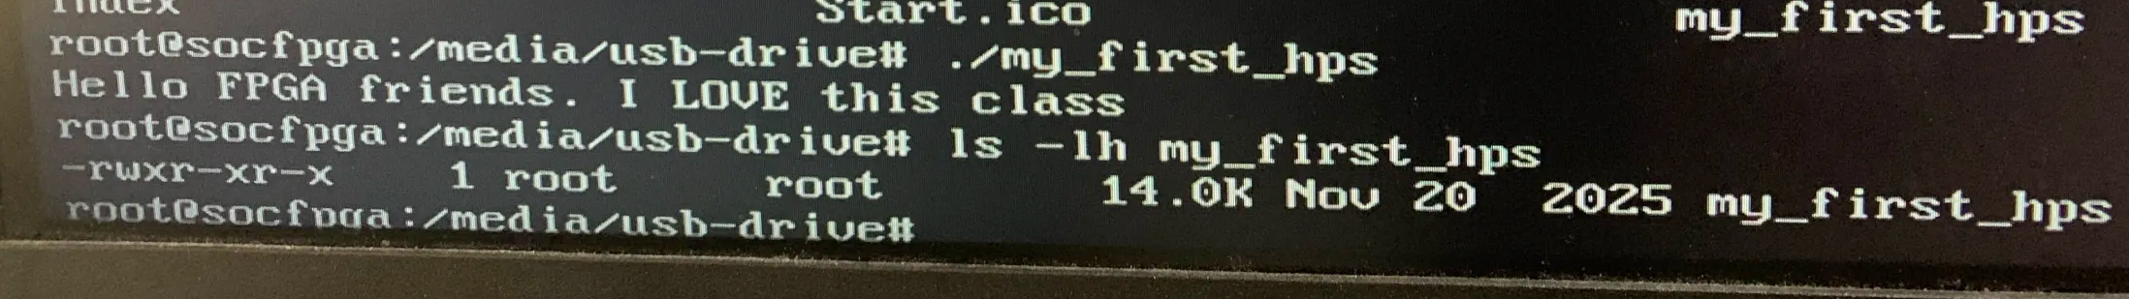  
Fig 3: size of the compiled file and working design   
  
run ./my_first_hps   
output: Hello FPGA friends. I LOVE this class  
run ls -lh ./my_first_hps  
to check size of the compiled file, which is 14.0k

**Part III – Controlling Peripherals through HPS**

1. As you can see from the picture below, the HPS in the Terasic board is ‘connected’ to different peripherals:



**Figure 1 Cyclone V SoC in Terasic DE1-SoC board overview**

Some of these peripherals include an HPS user button and a HPS user LED. Compile the hps_gpio/main.c program and annotate next to each line what it does through C/C++ comments. Include the size of the compiled program too. Create a YouTube video showing that it works.

|  |
| --- |
| Marks |
| 6 |
|  |

YouTube Link: <https://youtu.be/eW1qgwuUQog>  
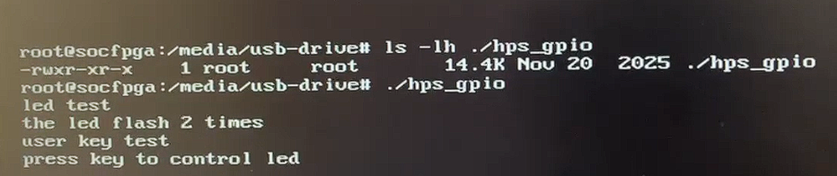  
Fig4: size of the hps_gpio   
  
size of the compiled program is 14.4k  
This program blink twice at speed of 500 milliseconds per blink  
press key to control LED on/off

**Part IV – Application**

Compile and run the aes.c on the HPS. Show the result of the encrypted values. Use ChatGPT to decrypt the code. The original plaintext should be re-generated when passing the ciphertext and key. Show that the design works by including screenshots/pictures of the termina of the plaintext, encryption key, ciphertext and plaintext reported by ChatGPT.

|  |
| --- |
| Marks |
| 6 |
|  |

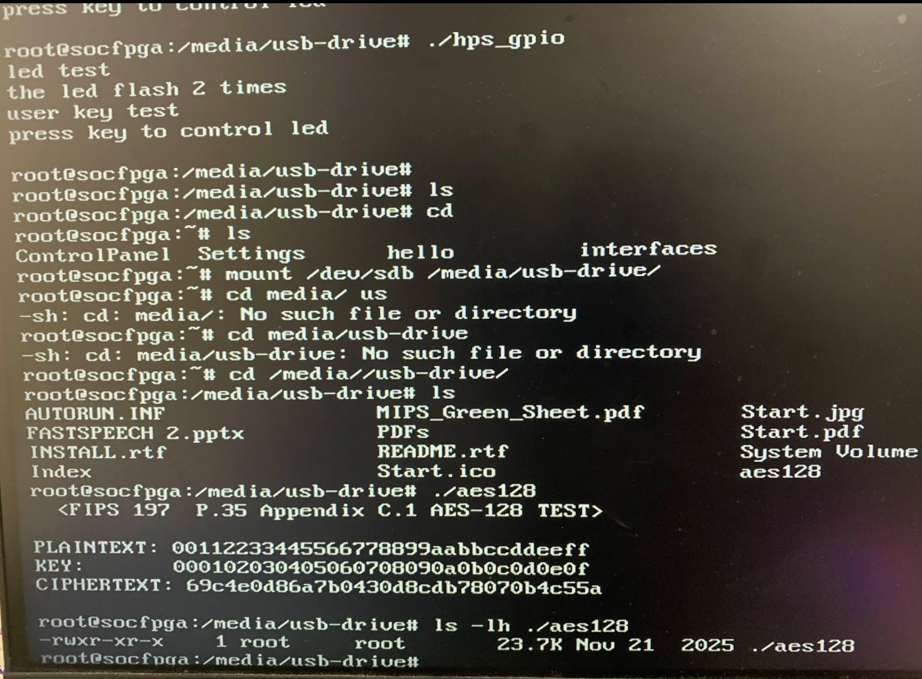  
Fig5: value of encrypted value

Chatgpt report:  
To verify the correctness of the AES-128 implementation on the HPS, we first encrypted a known FIPS 197 test vector. The 128-bit plaintext was set to 00 11 22 33 44 55 66 77 88 99 aa bb cc dd ee ff, and the 128-bit key was set to 00 01 02 03 04 05 06 07 08 09 0a 0b 0c 0d 0e 0f. After compiling and running the aes.c program on the HPS, the terminal reported the ciphertext as 69 c4 e0 d8 6a 7b 04 30 d8 cd b7 80 70 b4 c5 5a. We then provided this ciphertext and key to ChatGPT and asked it to perform AES-128 decryption. ChatGPT returned the plaintext 00 11 22 33 44 55 66 77 88 99 aa bb cc dd ee ff, which exactly matches the original input block. This round-trip result (plaintext → ciphertext on HPS, ciphertext → plaintext via ChatGPT) confirms that the AES encryption running on the HPS is functionally correct.  
  
  
Using the AES-128 test program on the HPS, I first encrypted the standard FIPS-197 Appendix C.1 test vector. The plaintext printed by the HPS was

00112233445566778899aabbccddeeff

and the 128-bit key was

000102030405060708090a0b0c0d0e0f.

After running ./aes128, the HPS reported the ciphertext

69c4e0d86a7b0430d8cdb78070b4c55a,

which matches the official NIST AES-128 reference value. I then provided this ciphertext and key to ChatGPT and asked it to perform AES-128 decryption. ChatGPT returned the decrypted plaintext

00112233445566778899aabbccddeeff,

which is identical to the original plaintext printed by the HPS. This confirms that the encryption on the HPS and the decryption performed by ChatGPT are consistent, and that the AES design correctly reproduces the original data when the same key is used.

.